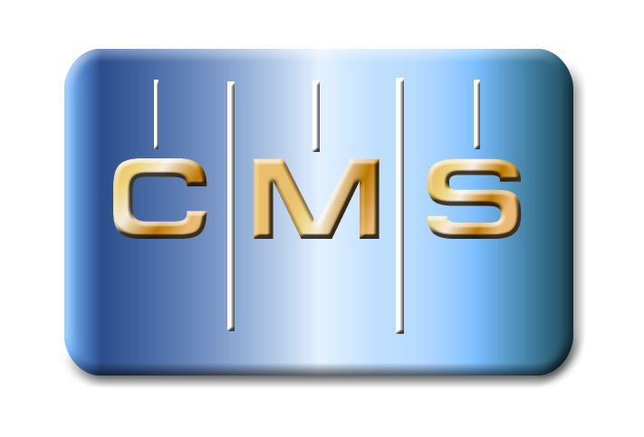

PRESS RELEASE | Press Contact: Belinda Jones, HiTech Marketing  860-399-1147, belinda.jones@hitechmarketing.com

PrecisionPath Consortium for Large-Scale Manufacturing to Hold October Working Meeting in Charlotte, NC
Industry-wide Survey for Users and Managers of Portable Metrology is Extended Until October 15, 2016

Weatherford, TX – September 28, 2016 – The Coordinate Metrology Society, in collaboration with UNC Charlotte, today announced the fourth working meeting of the PrecisionPath Consortium for Large-Scale Manufacturing will be held October 26 – 27, 2016 at UNC Charlotte in Charlotte, NC. This meeting will serve as a "Focus Group Workshop" led by team leaders from the collaborative team working to determine and prioritize the technology requirements of industries that manufacture large-scale, high accuracy parts and products. The gathering is a continuation of the Planning and Visioning Council meeting held at the Coordinate Metrology Society Conference in July 2016. Upon the conclusion of the meeting, attendees will have a chance to tour the UNC Charlotte metrology laboratories in the University's Center for Precision Metrology (CPM) and Energy Production and Infrastructure Center (EPIC).
At the last PrecisionPath meeting, several key areas were discussed including the roadmapping process, workforce issues and data management challenges from fusion to interoperability. Team leaders were selected and deliverables were outlined for the October focus group workshop. A brief discussion was held on the early survey results and the need to engage more industry partners and CMSC attendees. The consortium continues to grow and interested metrology professionals from the large-scale manufacturing community who can commit to attending PrecisionPath technical meetings and conferences are urged to contact CMS Committee Chair Ron Hicks at ron.hicks@apisensor.com. The PrecisionPath Consortium project is funded by an Advanced Manufacturing Technology Consortia (AMTech) Grant from the National Institute of Standards and Technology (NIST), an agency of the U.S. Commerce Department.
The PrecisionPath Consortium is comprised of representatives from leading manufacturing companies including Lockheed Martin, The Boeing Company, Spirit AeroSystems, Brookhaven National Laboratory, and Siemens. Participating OEMs and metrology service providers included Automated Precision (API), New River Kinematics (NRK), Hexagon Manufacturing Intelligence, ECM Global Measurement Solutions, Nikon Metrology and Planet Tool and Engineering. Consortium organizers are Ron Hicks, CMS PrecisionPath Chair, and UNC Charlotte representatives Ed Morse, John Ziegert, Ram Kumar, and Antonis Stylianou. Thomas Lettieri of NIST serves in a consulting role for the consortium.
Industry-wide Survey Extended to October 15, 2016

The PrecisionPath Consortium is conducting an industry-at-large survey at their website www.PrecisionPathConsortium.com, which has been extended until October 15, 2016. The survey addresses usage scenarios and issues impacting many industries, such as aerospace, automotive, defense, power generation, boatbuilding, oil and gas, and more. The study is gathering information about current capabilities and requirements, as well as anticipated future needs, for portable metrology systems in support of large-scale precision manufacturing (LPM). Users and managers of portable metrology systems should select the "Take our Survey" button on the website home page to contribute to the PrecisionPath Technology Roadmapping initiative. The survey is being conducted purely for research purposes and all answers are private. To ensure confidentiality, no identifying personal information is collected with the survey.

About the PrecisionPath Consortium
The PrecisionPath Consortium for Large-Scale Manufacturing is an industry-driven coalition led by the Coordinate Metrology Society and UNC Charlotte. The alliance is supported by an Advanced Manufacturing Technology Consortia (AMTech) Grant from the National Institute of Standards and Technology (NIST). The PrecisionPath Consortium will develop strategic roadmaps to solve universal technology challenges faced by manufacturers of large, high-precision parts and assemblies. PrecisionPath members hail from industries such as aerospace, defense, power generation, and more. For more than 30 years, the Coordinate Metrology Society has served industrial measurement professionals involved in large-scale manufacturing ⎯ end users, OEMs, software developers and service providers. UNC Charlotte supports industry-academia collaborations in search of next-generation manufacturing technologies. For more information, contact Professor Ed Morse of UNC Charlotte's Center for Precision Metrology at emorse@uncc.edu.
About the Coordinate Metrology Society
The Coordinate Metrology Society is comprised of users, service providers, and OEM manufacturers of close-tolerance industrial coordinate measurement systems, software, and peripherals. The metrology systems represented at the annual Coordinate Metrology Society Conference (CMSC), include articulated arm CMMs, laser trackers, laser radar, photogrammetry/videogrammetry systems, scanners, indoor GPS and laser projection systems. The Coordinate Metrology Society gathers each year to gain knowledge of the advancements and applications of any measurement system or software solution that produces and uses 3D coordinate data. For more information on this organization, visit their web site at http://www.cmsc.org.

