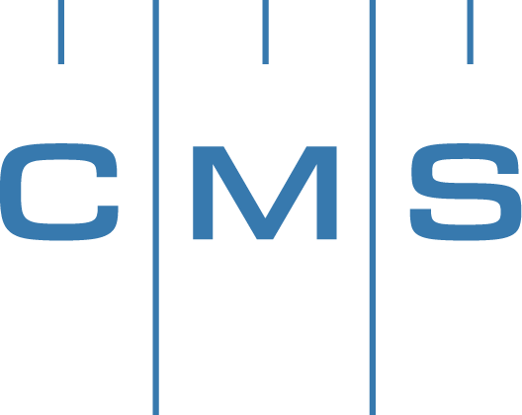

PRESS RELEASE | Press Contact: Belinda Jones, HiTech Marketing  860-399-1147, belinda.jones@hitechmarketing.com

PrecisionPath Consortium for Large-Scale Manufacturing to Hold March 2017 Working Meeting in Dallas, TX
Consortium heads toward full draft of Technology Roadmap for the Future

Weatherford, TX – February 14, 2017 – The Coordinate Metrology Society, in collaboration with UNC Charlotte, today announced the fifth working meeting of the PrecisionPath Consortium for Large-Scale Manufacturing will be held March 23, 2017 in Dallas, TX at the Hyatt Regency DFW, Terminal C. The PrecisionPath Consortium works to determine and prioritize the technology requirements of industries that manufacture large-scale, high accuracy parts and products. The March program will build upon the results of the October 2016 "Focus Group Workshop", a continuation of the Planning and Visioning Council forums held over the past year and a half. Team leaders and members will perform a full review of the Consortium's work and prepare a full draft roadmap document for public review. The primary objectives of the meeting are to review output from all working groups and conduct a work session to complete each section. The group will assemble and review the initial draft of the roadmap, and identify any conflicts or gaps followed by a plan to address those issues. Members will proceed to identify external reviewers of the roadmap for additional industry commentary on the final roadmap product.
At the October 2016 PrecisionPath meeting, team leaders of each working group presented their body of research on technologies, usage/applications, standards, data management, workforce and drivers. An industry-at-large survey of users and managers of portable metrology systems was conducted from May – October 2016 to support the PrecisionPath Technology Roadmapping initiative. A preliminary summary of the Survey results was presented to the group, followed by a brainstorming session for all working groups culminating in concise reports presented to the participants. Interested metrology professionals from the large-scale manufacturing community who can commit to attending PrecisionPath technical meetings and conferences are urged to contact CMS Committee Chair Ron Hicks at ron.hicks@apisensor.com. The PrecisionPath Consortium project is funded by an Advanced Manufacturing Technology Consortia (AMTech) Grant from the National Institute of Standards and Technology (NIST), an agency of the U.S. Commerce Department.
The PrecisionPath Consortium is comprised of representatives from leading manufacturing companies including Lockheed Martin, The Boeing Company, Spirit AeroSystems, Brookhaven National Laboratory, and Siemens. Participating OEMs and metrology service providers included Automated Precision (API), New River Kinematics (NRK), Hexagon Manufacturing Intelligence, ECM Global Measurement Solutions, Nikon Metrology and Planet Tool and Engineering. Consortium organizers are Ron Hicks, CMS PrecisionPath Chair, and UNC Charlotte representatives Ed Morse, John Ziegert, Ram Kumar, and Antonis Stylianou. Thomas Lettieri of NIST serves in a consulting role for the consortium.
About the PrecisionPath Consortium
The PrecisionPath Consortium for Large-Scale Manufacturing is an industry-driven coalition led by the Coordinate Metrology Society and UNC Charlotte. The alliance is supported by an Advanced Manufacturing Technology Consortia (AMTech) Grant from the National Institute of Standards and Technology (NIST). The PrecisionPath Consortium will develop strategic roadmaps to solve universal technology challenges faced by manufacturers of large, high-precision parts and assemblies. PrecisionPath members hail from industries such as aerospace, defense, power generation, and more. For more than 30 years, the Coordinate Metrology Society has served industrial measurement professionals involved in large-scale manufacturing ⎯ end users, OEMs, software developers and service providers. UNC Charlotte supports industry-academia collaborations in search of next-generation manufacturing technologies. For more information, contact Professor Ed Morse of UNC Charlotte's Center for Precision Metrology at emorse@uncc.edu.
About the Coordinate Metrology Society
The Coordinate Metrology Society is comprised of users, service providers, and OEM manufacturers of close-tolerance industrial coordinate measurement systems, software, and peripherals. The metrology systems represented at the annual Coordinate Metrology Society Conference (CMSC), include articulated arm CMMs, laser trackers, laser radar, photogrammetry/videogrammetry systems, scanners, indoor GPS and laser projection systems. The Coordinate Metrology Society gathers each year to gain knowledge of the advancements and applications of any measurement system or software solution that produces and uses 3D coordinate data. For more information on this organization, visit their web site at http://www.cmsc.org.

