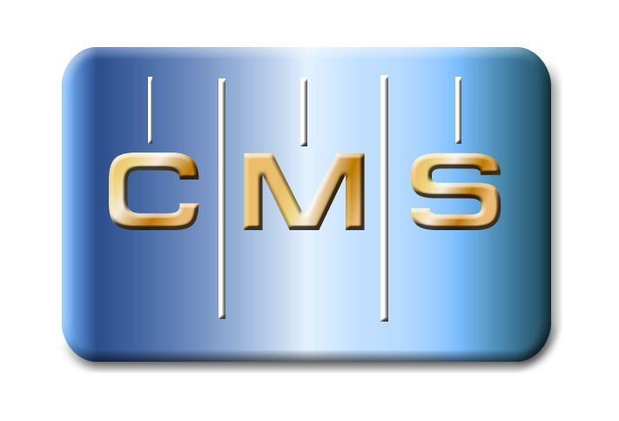

PRESS RELEASE | Press Contact: Belinda Jones, HiTech Marketing  860-399-1147, belinda.jones@hitechmarketing.com

PrecisionPath Consortium for Large-Scale Manufacturing Sets Second Working Meeting for February
Industry-driven Consortium Continues to Chart New Ground for Advancing Large-scale Manufacturing

Weatherford, TX – January 25, 2016 – The Coordinate Metrology Society, in collaboration with UNC Charlotte, today announced the second working meeting of the PrecisionPath Consortium for Large-Scale Manufacturing will be held February 24 – 25, 2016 at the UNC Charlotte Center City building in downtown Charlotte, NC. This working meeting will serve as a "Needs Assessment and Gap Analysis Workshop" for the collaborative team working to identify and prioritize the technology needs of the aerospace, defense, energy, and other industries that manufacture large-scale, high accuracy parts and products. This gathering is a continuation of their Planning and Visioning Council meeting held in late October 2015 to discuss critical production challenges and metrology system attributes, and solidify the framework of the PrecisionPath Roadmap. The new project is funded by an Advanced Manufacturing Technology Consortia (AMTech) Grant from the National Institute of Standards and Technology (NIST), an agency of the U.S. Commerce Department.
Interested metrology professionals from the large-scale manufacturing community who can commit to attending PrecisionPath technical meetings and associated conferences in the next two years are invited to contact Ron Hicks, CMS Committee Chair at ron.hicks@apisensor.com. As the meeting concludes on Thursday afternoon, January 25, attendees will have a chance to tour the UNC Charlotte metrology laboratories in the University's Center for Precision Metrology (CPM) and Energy Production and Infrastructure Center (EPIC).
“The PrecisionPath Consortium is making strides for advanced manufacturing," states Ron Hicks, CMS AMTech Committee Chair. "The last working meeting was held in the true spirit of collaboration, where stakeholders are dedicated to progressing the state of industry and technology. The energy of the group is inspiring, as they strive to make headway and eliminate roadblocks facing the large-scale manufacturing sector in the United States."
The PrecisionPath Consortium is comprised of representatives from leading manufacturing companies including Lockheed Martin, The Boeing Company, Spirit AeroSystems, Brookhaven National Laboratory, and Siemens. Participating OEMs and metrology service providers included Automated Precision (API), New River Kinematics (NRK), Hexagon Manufacturing Intelligence, ECM Global Measurement Solutions, Nikon Metrology and Planet Tool and Engineering. Consortium organizers are Ron Hicks, CMS PrecisionPath Chair, and UNC Charlotte representatives Ed Morse, John Ziegert, Ram Kumar, and Antonis Stylianou. Thomas Lettieri of NIST serves in a consulting role for the consortium.
Roadmap for Innovation
The PrecisionPath Consortium held their Planning and Visioning Council during the Quality Show in late October at the Rosemont Convention Center in Chicago, IL. The first session of the meeting focused on refining the project scope and boundaries. The Council discussed the critical challenges in producing large products to precision tolerances, and then transitioned into identifying metrology technology families used by industry. This segment was followed by the team compiling the most important attributes of these systems for measurement and inspection.

About the PrecisionPath Consortium
The PrecisionPath Consortium for Large-Scale Manufacturing is an industry-driven coalition led by the Coordinate Metrology Society and UNC Charlotte. The alliance is supported by an Advanced Manufacturing Technology Consortia (AMTech) Grant from the National Institute of Standards and Technology (NIST). The PrecisionPath Consortium will develop strategic roadmaps to solve universal technology challenges faced by manufacturers of large, high-precision parts and assemblies. PrecisionPath members hail from industries such as aerospace, defense, power generation, and more. For more than 30 years, the Coordinate Metrology Society has served industrial measurement professionals involved in large-scale manufacturing ⎯ end users, OEMs, software developers and service providers. UNC Charlotte supports industry-academia collaborations in search of next-generation manufacturing technologies. For more information, contact Professor Ed Morse of UNC Charlotte's Center for Precision Metrology at emorse@uncc.edu.
About the Coordinate Metrology Society
The Coordinate Metrology Society is comprised of users, service providers, and OEM manufacturers of close-tolerance industrial coordinate measurement systems, software, and peripherals. The metrology systems represented at the annual Coordinate Metrology Society Conference (CMSC), include articulated arm CMMs, laser trackers, laser radar, photogrammetry/videogrammetry systems, scanners, indoor GPS and laser projection systems. The Coordinate Metrology Society gathers each year to gain knowledge of the advancements and applications of any measurement system or software solution that produces and uses 3D coordinate data. For more information on this organization, visit their web site at http://www.cmsc.org.

Link to press release:

